Name: Sanket Walekar

**Assignment 1**

* 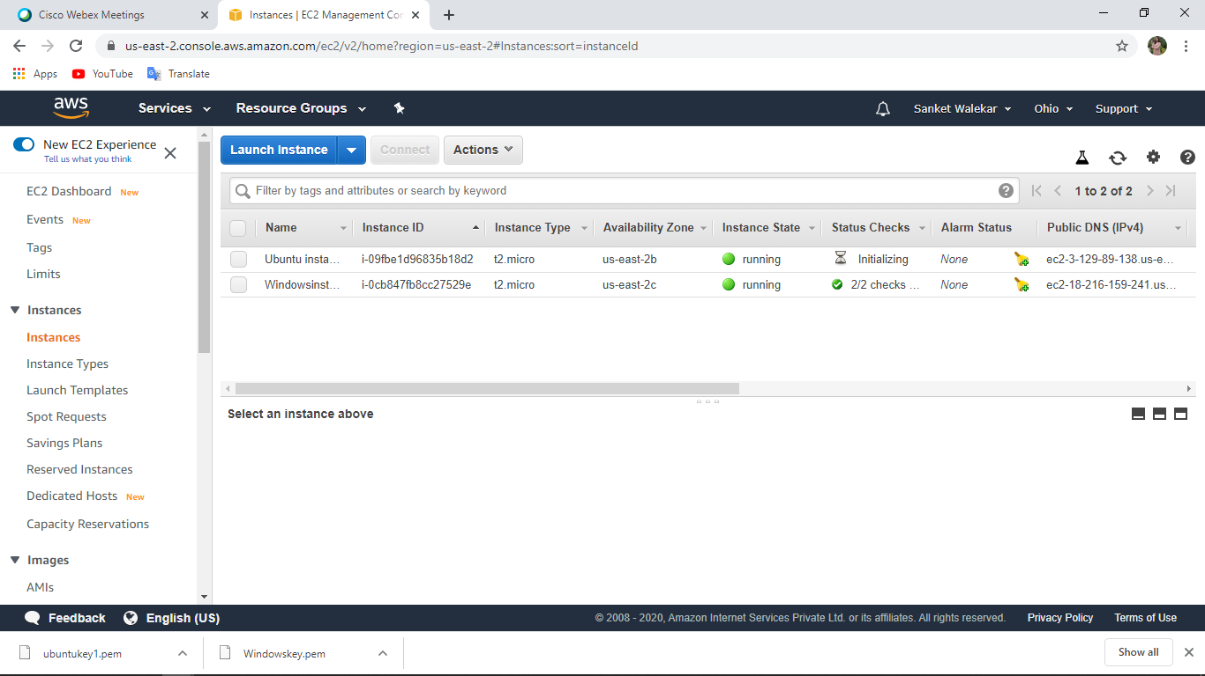**Both instances (Windows and Ubuntu).**

**Project 1**

**Deploying a web server in Windows instance**

1. **Create a windows instance using AMI(IP:- 18.216.159.241)**

**Output:-**

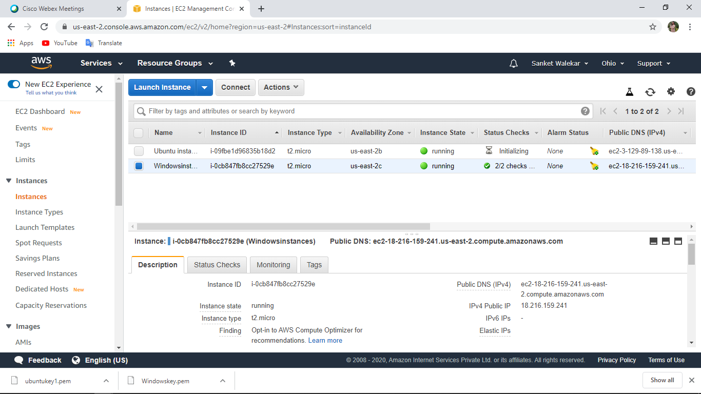

1. **Launch the Windows instance using RDP**

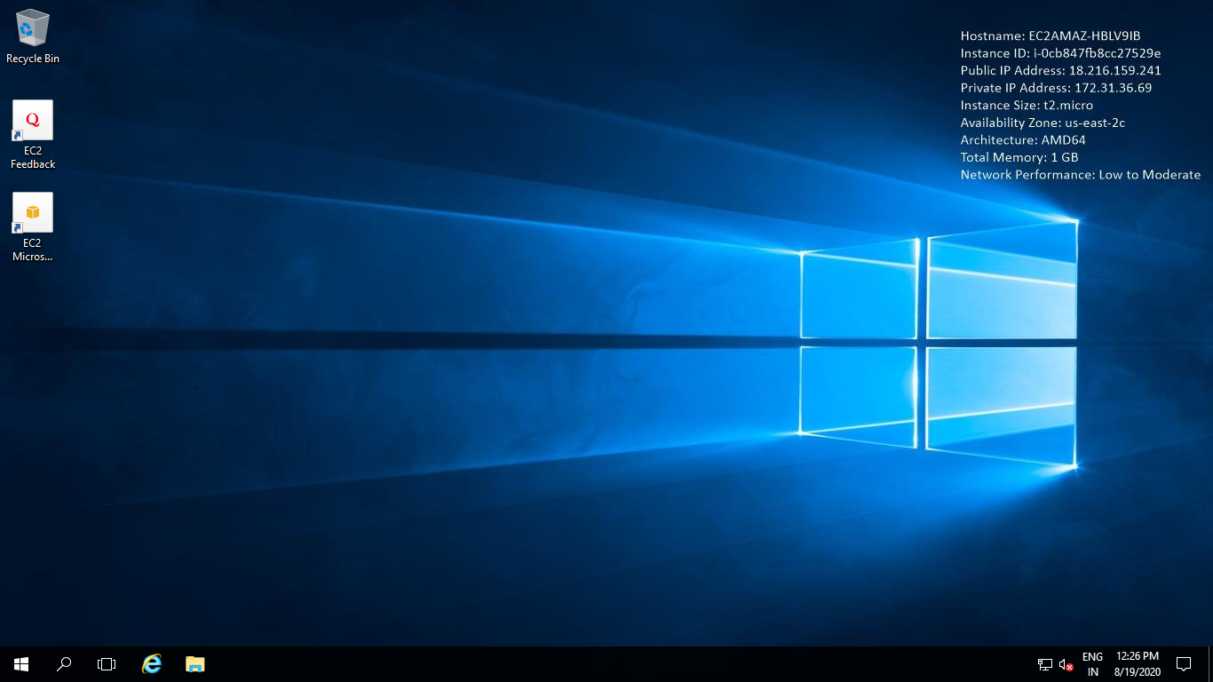**Output:-**

1. **Install IIS web server using Powershell ISE**

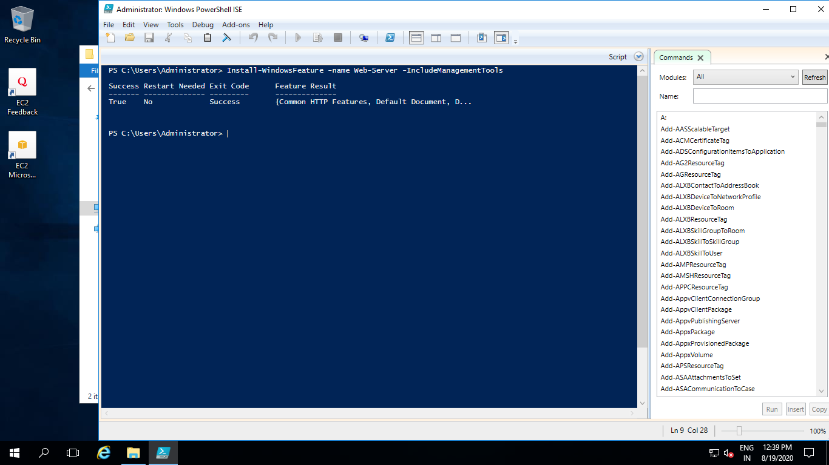**Output:-**

1. **Verify successful installation of IIS Web Server**

**Output:-**

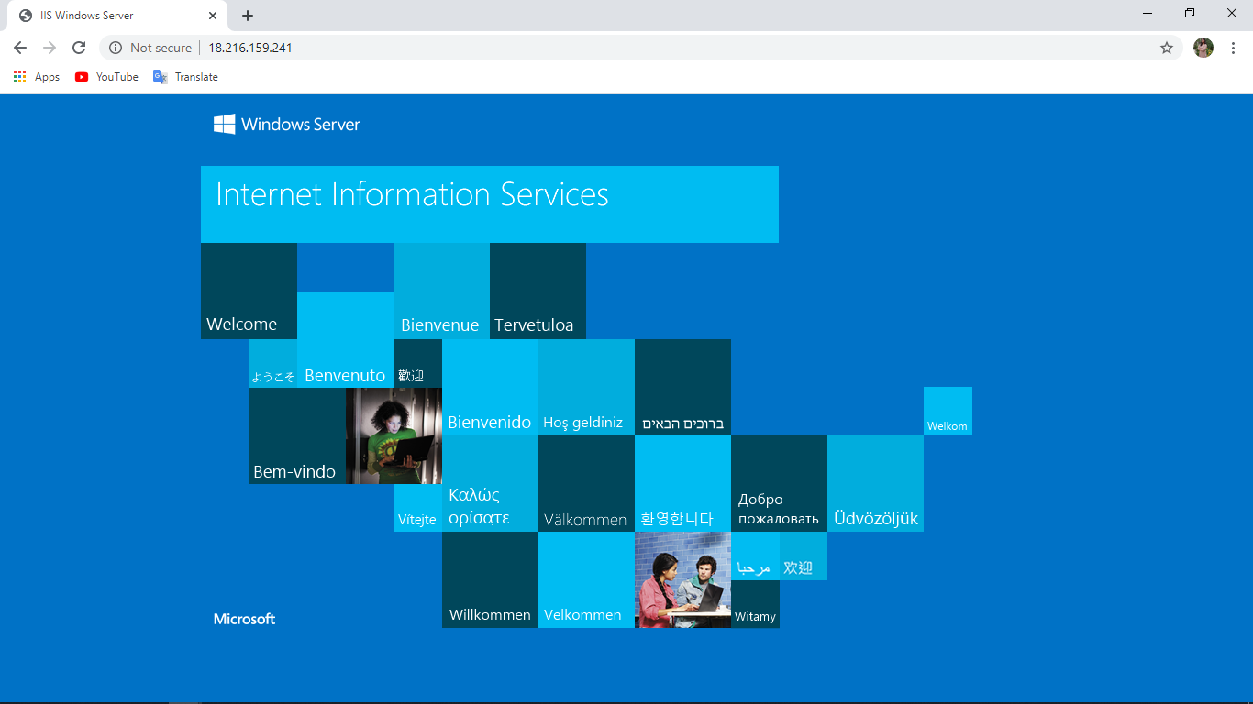

**Project 2**

**Deploying a web server in Windows instance**

1. **Create a windows instance using AMI (IP:- 3.129.89.138)**

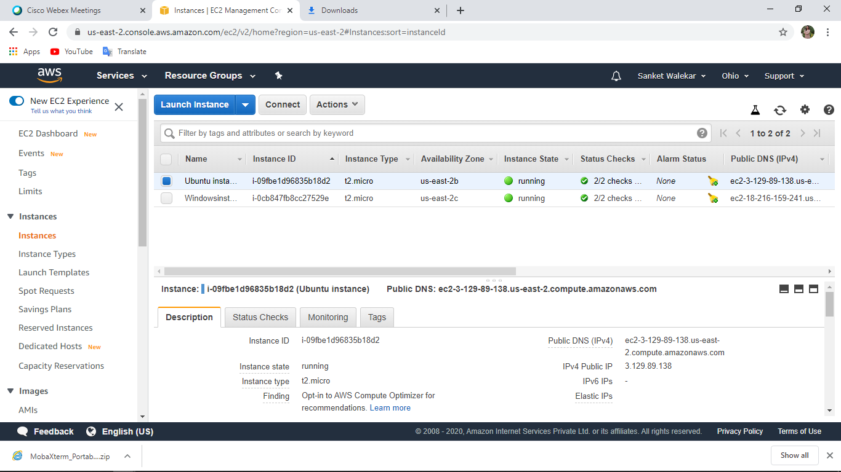**Output:**-

1. **Download and install MobaXterm Portable Edition**

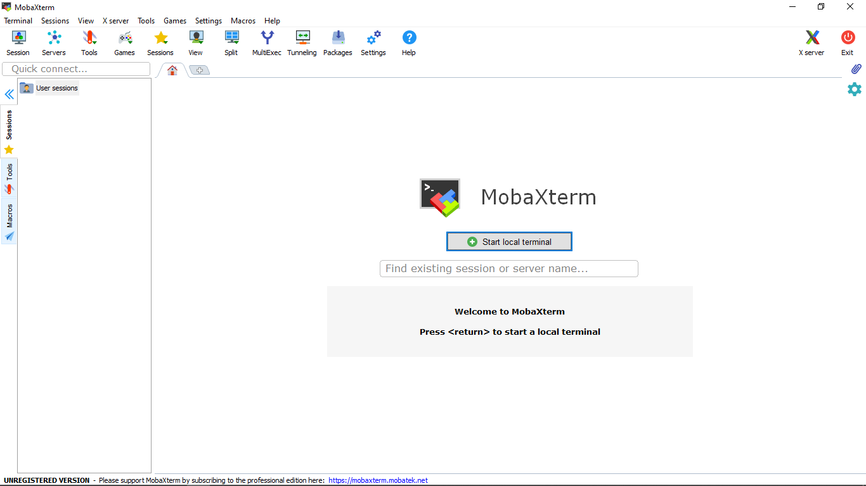**Output:-**

1. **Launch the Ubuntu instance using SSH**

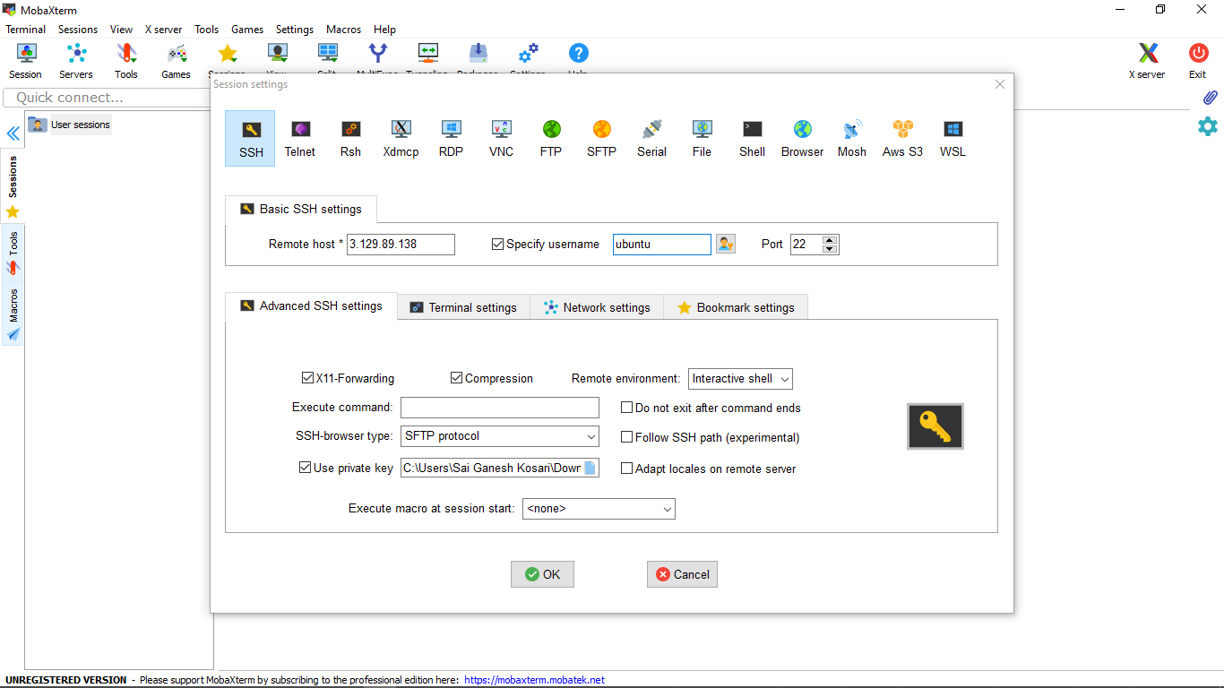**Output:-**

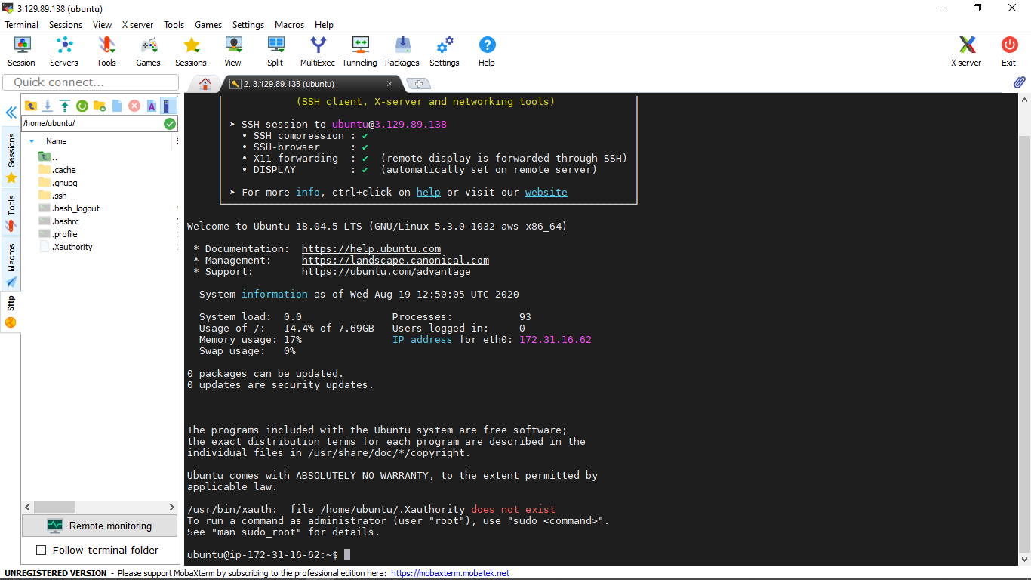

1. **Install ngnix web server using bash**

**Output:-**

* 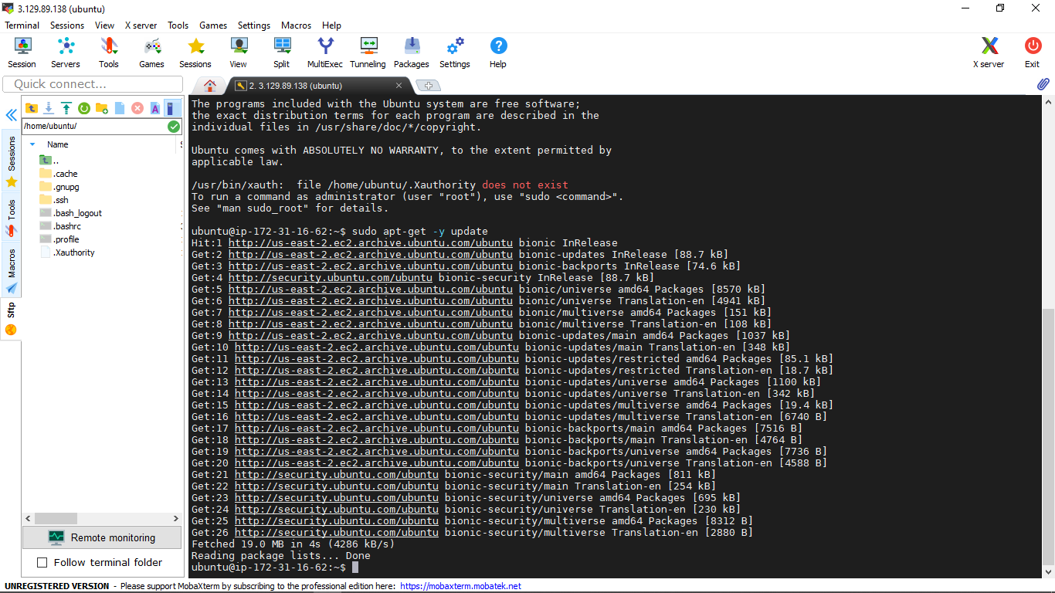sudo apt-get -y update
* 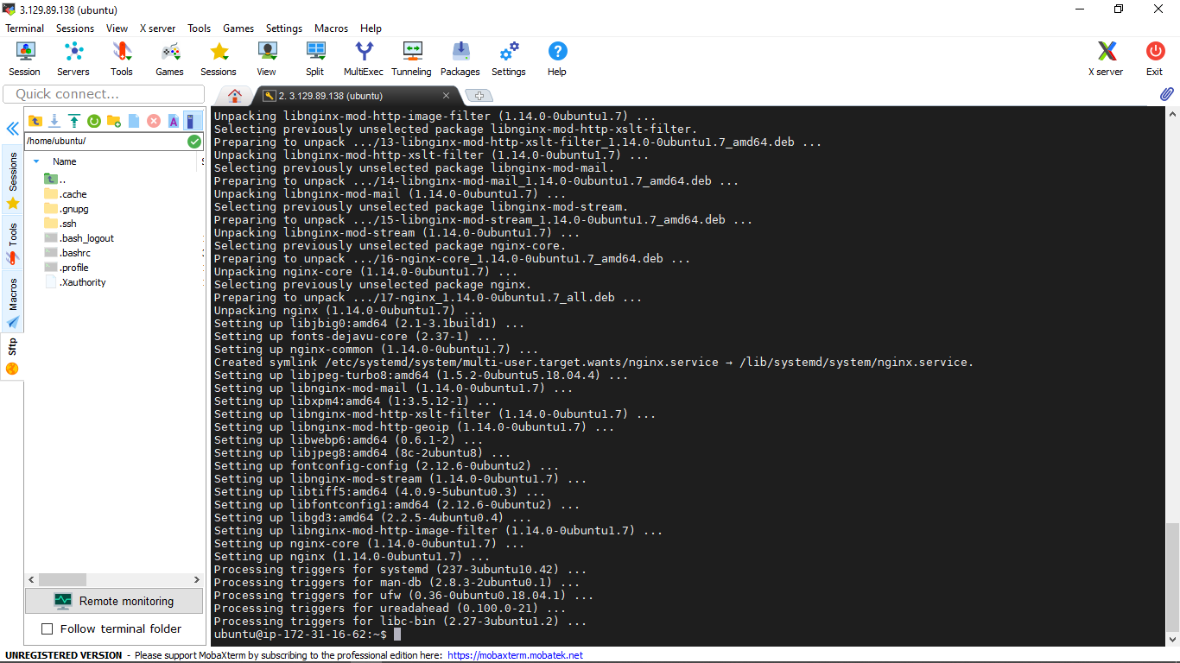sudo apt-get -y install nginx

1. **Verify successful installation of ngnix**

**Output:-**

